PORT VS SOCKET
SOCKET:
It is a pair of communicating with each other in the presence of the network and it can be done using client and server communication. And these can be done using sending and receiving messages through a interface is called socket. And it is not a connection to itself and it is an endpoint for connection.

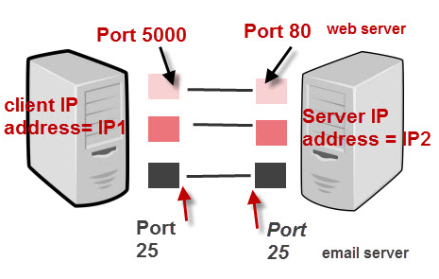

IP ADDRESS + PORT NUMBER = SOCKET.
An socket consists of three things:
1.Ip address
2. A transfer protocol
3. port number

WEB SOCKET:
It is a two-way communication between the user and the server. And it allow the communication to be done between the two points.
port:
It means providing address to a machine. It means there is send and receiving data between the process and there is no interface between them. All the sockets are specifiely provided within a port number.
- And it is used to provided by a software like skype,chrome.
- If the data is received exactly by the transport layer is called de-multiplexing.
- In this port represents a single service.
- And this only accept the connections received by the tcp server.
- It is usually the address received by the computer to tell that where to store the data.

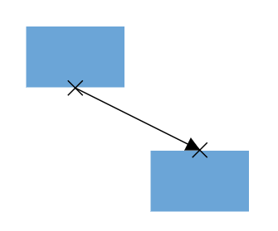
EX: Diagram of port.

- It is the address of the given protocols to identity the application on which data has been received.
- while port is a numerical value applied to the specific point in the interface device.

